Decision Tree Intuition

CART – Classification Trees and Regression Trees

Splitting of the Trees

* 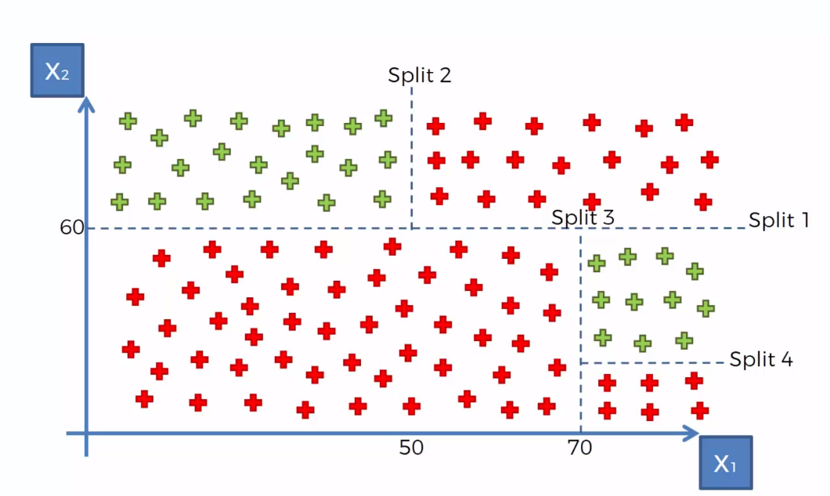How does the algorithm knows? Maximum number of category, next split, maximises number of categories- Minimize Entropy
* 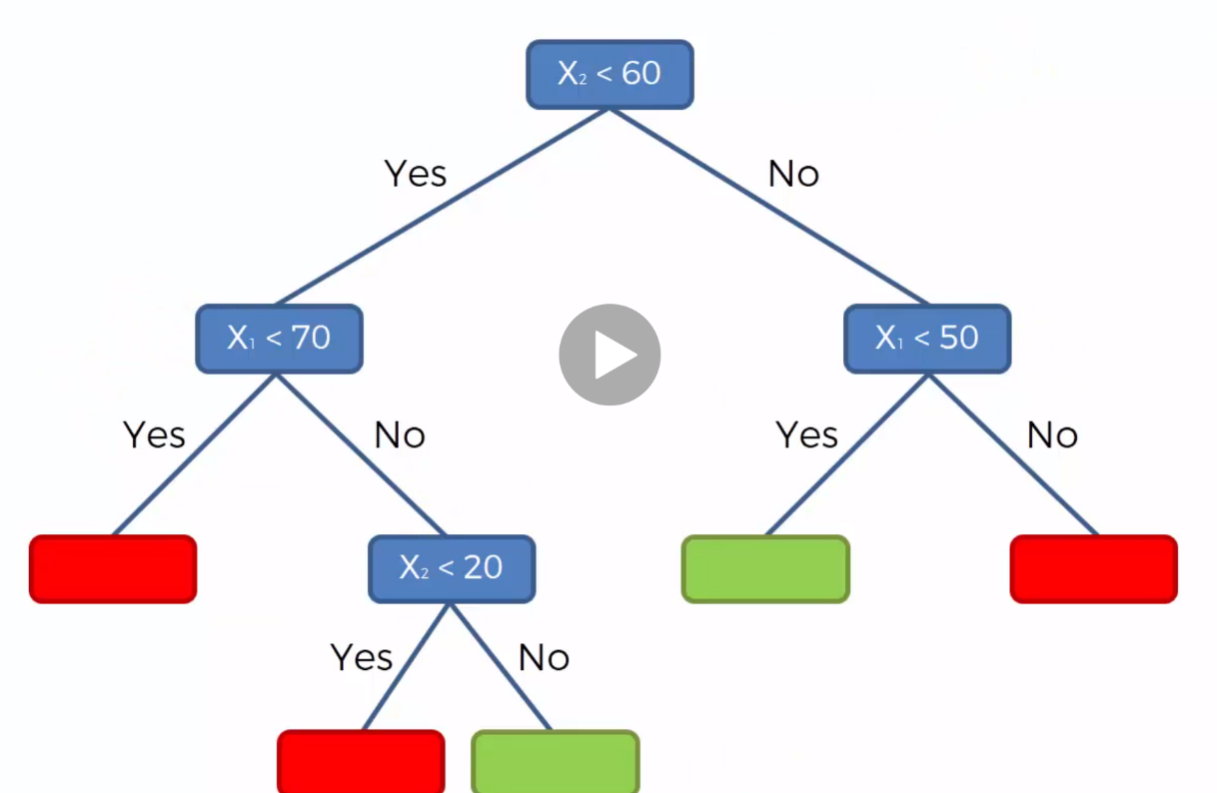Get the optimal Split. And Construct Decision Tree.
* Reborn with Upgrades
* Random Forest
* Gradient Boosting